

Handbook

ARMS action 2019

ASSEMBLE+

Join Research Activity 1 (Genomics Observatories)

Version

v2.0

Date

2018-03-01

Contact

Matthias Obst, Department of Marine Sciences, University of Gothenburg, Sweden ([matthias.obst@marine.gu.se](mailto:matthias.obst@marine.gu.se))

Table of Contents

Project summary 3

Some general principles 3

Overview over network and sites 4

Sampling report 2018 6

Time schedule 2019 7

Your to-do list for 2019 7

Amendments to the original ARMS protocol 8

Appendices 13

# Project summary

This project is setting up a network of Artificial Reef Monitoring Structures (ARMS) in the vicinity of marine stations and Long term Ecological Research sites (LTER) in order to assess status and changes in hard bottom communities of near coast environments. The initial scientific purpose of the project is to identify newly arrived Non-Indigenous Species (NIS) and track the migration of already known NIS in European continental waters. The project will consist in three annual cycles, with each cycle consisting of a design, deployment, and analysis phase (Fig 1). The project is primarily funded through the Joint Research Activity JRA1 of the ASSEMBLE+ program (<http://assembleplus.eu>), but has relations to European infrastructure and monitoring programs, such as e.g. European Marine Biological Resource Center ([www.embrc.eu](http://www.embrc.eu)), the Genomic observatories network (<http://genomicobservatories.org/>), and the Interreg project GEANS (<https://northsearegion.eu/geans/>). This handbook gives an overview over the state of the activity, the network of sites and scientists, as well as the necessary protocols for ARMS deployment, retrieval and processing.

# Some general principles

1. Each partner tries to deploy 1-3 ARMS per site during summer season 2019
2. We follow the standards and protocols established by the Smithsonian Institution for deployment and retrievalof ARMS (<http://arms.biocodellc.com/>)
3. If possible, we try to collect physico-chemical parameters (temp, salinity, etc), for example from nearby measurement stations or buoys
4. The molecular genetic analysis of all samples is centralized and will be done by [HCMR](mailto:https://www.hcmr.gr/en/) during the winter months (see Fig 1).
5. All data (metadata, image data, sequence data, physic-chemical data) will be liked by VLIZ (see Fig 6).

|  |
| --- |
|  |
| ***Fig 1.*** *Overall time schedule for the ARMS activity, including three deploymnet cycles, each with a preparation phase (spring), deployment phase (summer) and analysis phase (autum, winter).* |

# Overview over network and sites

|  |
| --- |
|  |
| ***Fig 2.*** *Overview map showing ARMS deployment sites for 2018-2019. The numbers next to each point indicate the number of ARMS deployed.* |

|  |  |  |  |  |
| --- | --- | --- | --- | --- |
| **#** | **Contact name** | **Contact email** | **Country** | **Region of deployment** |
| 1 | Melody Clark | [mscl@bas.ac.uk](mailto:mscl@bas.ac.uk) | UK | Antarctica |
| 2 | Nathan Chrismas | [natchr@mba.ac.uk](mailto:natchr@mba.ac.uk) | UK | British channel |
| 3 | Frédérique Viard | [viard@sb-roscoff.fr](mailto:viard@sb-roscoff.fr) | France | British channel |
| 4 | Jesus Troncoso | [troncoso@uvigo.es](mailto:troncoso@uvigo.es) | Spain | Atlantic coast - Viana |
| 5 | Joanna Norkko | [joanna.norkko@helsinki.fi](mailto:joanna.norkko@helsinki.fi) | Finland | Baltic Sea |
| 6 | Borut Mavrič | [borut.mavric@nib.si](mailto:borut.mavric@nib.si) | Slovenia | Mediterranean |
| 7 | Anne Marie Power | [annemarie.power@nuigalway.ie](mailto:annemarie.power@nuigalway.ie) | Ireland | Atlantic ocean |
| 8 | Wenne Roman | [rwenne@iopan.gda.pl](mailto:rwenne@iopan.gda.pl) | Poland | Svalbard |
| 9 | Rafał Lasota | [ocerl@ug.edu.pl](mailto:ocerl@ug.edu.pl) | Poland | Baltic Sea |
| 10 | Matthias Obst | [matthias.obst@marine.gu.se](mailto:matthias.obst@marine.gu.se) | Sweden | North Sea - Skagerrak |
| 11 | Pascal Hablutzel | [pascal.hablutzel@vliz.be](mailto:pascal.hablutzel@vliz.be) | Belgium | North Sea - Belgian coast |
| 12 | [Christos Arvanitidis](mailto:arvanitidis@hcmr.gr) | [arvanitidis@hcmr.gr](mailto:arvanitidis@hcmr.gr) | Greece | Mediterranean |
| 13 | Amatzia Genin | [a.genin@mail.huji.ac.il](mailto:a.genin@mail.huji.ac.il) | Israel | Red Sea |
| 14 | Jakob Thyrring | [thyrring@bios.au.dk](mailto:thyrring@bios.au.dk) | Denmark | Greenland |
| 15 | Peter Anton Stæhr | [pst@bios.au.dk](mailto:pst@bios.au.dk) | Denmark | North Sea - Kattegat |
| 16 | Henning Reiss | [henning.reiss@nord.no](mailto:henning.reiss@nord.no) | Norway | North Sea - Norwegian West coast |
| 17 | Wiebe Kooistra | [wiebe.kooistra@szn.it](mailto:wiebe.kooistra@szn.it) | Italy | Gulf of Naples |
|  |  |  |  |  |

**Leader of activities**

|  |  |  |  |  |
| --- | --- | --- | --- | --- |
|  | **Contact name** | **Contact email** | **Country** | **Activity** |
|  | Matthias Obst | [matthias.obst@marine.gu.se](mailto:matthias.obst@marine.gu.se) | SE | Coordination, ARMS supply, analysis |
|  | Laetitia Plaisance | [PlaisanceL@si.edu](mailto:PlaisanceL@si.edu) | USA | Protocols & experience |
|  | Georgios Kotoulas | [kotoulas@hcmr.gr](mailto:kotoulas@hcmr.gr) | GR | Extraction, Sequencing |
|  | Klaas Deneudt | [klaas.deneudt@vliz.be](mailto:klaas.deneudt@vliz.be) | BE | Data management |

***Table 1.*** *List of contacts and deployments sites****.***

# Sampling report 2018

|  |  |  |  |  |  |  |  |  |  |  |  |  |  |  |
| --- | --- | --- | --- | --- | --- | --- | --- | --- | --- | --- | --- | --- | --- | --- |
|  |  |  |  | **Motile fraction** | | | | **Sessile fraction** | | **Other samples** | | | **Contextual data** | |
| **Contact**  **name** | **Region** | **ARMS ID** | **No of vouchers specimens4** | **500 micron** | | **100 micron** | | **40 micron** | | **Sediment** | **Plankton** | **OSD1** | **Images2** | **Phys-chem parameters3** |
| **DMSO** | **EtOH** | **DMSO** | **EtOH** | **DMSO** | **EtOH** |
| Norkko | Baltic | TZS_2018_Angbat | 24 | - | 1 | - | 2 | - | 3 | - | - | - | No | No |
| TZS_2018_Spikarna | 47 | - | 1 | - | 1 | - | 3 | - | - | - | Yes | No |
| Lasota | Baltic | 2018_GDY | - | - | - | - | - | - | - | - | - | - | - | - |
| Obst | Skagerrak | 2018_Koster_VH2 | <10 | - | 1 | - | 1 | 1 | 1 | 2 | 1 | - | Yes | Yes |
| Hablutzel / Mortelmans | Belgian coast | AZFP_1 | 37 | -- | 5 | - | 5 | - | - | - | - | - | Yes | Yes |
| AZFP_2 | 0 | - | 2 | - | 1 | - | - | - | - | - | No | No |
| Chrismas | British channel | MBA_ARMS1_2018 | <10 | 1 | 1 | 1 | 1 | 1 | 1 | - | - | - | Yes | No |
| MBA_ARMS2_2018 | <10 | 0 | 1 | 1 | 1 | 1 | 1 | - | - | - | Yes | No |
| Viard | British channel | MarBlo_2018 | 18 | 1 | 1 | 1 | 1 | 2 | 2 | - | - | - | - | - |
| BasBlo_2018 | 28 | 1 | 0 | 1 | 0 | 2 | 2 | - | - | - | - | - |
| Troncoso | Atlantic coast | Vigo_JT1 | ~90 | - | 1 | - | 1 | - | 1 | - | - | Yes | Yes | Yes |
| Power | Irish Sea | NA | - | - | - | - | - | - | - | - | - | - | - | - |
| Mavrič | Mediterranean | SL_2018_8 | 8* | 1 | 1 | 1 | 1 | 1 | 1 | - | - | - | Yes | No |
| Arvanitidis | Mediterranean | HCMR-1HER_28/1/2019_ARMS1 | 14 | 1 | 1 | 1 | 1 | 4 | 4 | 1 | 1 | - | Yes | Yes |
| Genin | Red Sea | Eilat_NR | - | - | - | - | - | - | - | - | - | - | - | - |
| Eilat_port | - | - | - | - | - | - | - | - | - | - | - | - |

***Table 2.*** *Overview over samples and data. The table show how the number of samples submitted and data collected by each ARMS site. 1OSD (Ocean Sampling Day) samples for microbial analysis, 2Images from ARMS plates, 3Physico-chemical parameters may include Salinity, Temperature, Chlorophyll, Turbidity, Current, etc, 4Tissue samples of identified specimens that were submitted to add to the barcode referecne library.*

# Time schedule for 2019

Here is a short outline of the milestones for this year

|  |  |
| --- | --- |
| April | **Sequencing.** The first batch of sequenced samples from 2018 (listed in Table 2) is expected by end of April 2019. UGOT and HCMR will do a preliminary analysis. If any partner wants to participate, please contact [matthias.obst@marine.gu.se](mailto:matthias.obst@marine.gu.se). |
| May | **Online workshop.** Online ***analysis*** ***workshop on Wednesday, 22 May 2019, 13.00-15.00*** *(link below)* we want to present the preliminary results from the 2018 trial, and make a decision of the sampling and sequencing protocol to decide on the deployment period, preservation method, environmental and biological parameters. The workshop will also give consultation about deployment and retrieval for new partners.  **ARMS online workshop.** When May 22, 2019 1:00 PM (Stockholm time), Where:: <https://zoom.us/j/864945657> |
| June | **Deployment of ARMS.** Similar to last year, we plan to deploy for 3-4 months during summer season, starting in June. Some partners may deploy for 1 year (e.g. Ant/arctic regions or non-coastal deployments). |
| June | **Data management.** We have a data management meeting in June, where we will use the sites samples in 2028 to build up a data flow between genetic, physic-chemical, and image data. |
| August -September | **Retrieval of ARMS.** Similar to last year, we plan to retrieve the ARMS between after 3-4 months, i.e. in August-September. |
| October – December | **Sequencing.** The 2019 samples will be sequenced between October-December. |
| January - March | **Analysis.** The analysis of 2018-2019 (genetic, imaging, and physic-chemical) data will start in Jan 2020, and for this purpose we may arrange a specific meeting or online workshop. |

# Your to-do list for 2019

|  |  |
| --- | --- |
| April | **New partners/sites only.** Register your site and order ARMS **as soon as possible,** using the online form at <http://arms.biocodellc.com/getting-involved>. Use the text provided in the “project registration sheet” (see Appendix). |
| April | **New partners/sites only.** Order ARMS, by contacting [Matthias.Obst@marine.gu.se](mailto:Matthias.Obst@marine.gu.se)**.** |
| May | **New partners/sites only.** Carefully study the protocols for ARMS assembly, deployment, retrieval, and processing at <http://arms.biocodellc.com/protocols-overview> |
| May | **ALL.** Submit a metadata sheet (see Appendix) for all deployments to [Matthias.Obst@marine.gu.se](mailto:Matthias.Obst@marine.gu.se) and PlaisanceL@si.edu |
| May | **ALL.** Plan and organise the your ARMS deployment at your site for May-June. Deploy and document (photos, protocols, metadata, etc) |
| August | **ALL.** Plan and organise the your ARMS and the retrieval for Sep-Oct 2019. Retrieve and document the entire procedure (with field notes, photos, etc). |
| Sep | **ALL.** |

# Amendments to the original ARMS protocol

*During the first deployment cycle we had a series of open discussion topics on customisations of the original ARMS protocol. These topics will be continuously discussed (during meetings and online workshops) as we start to gather experience and data. Below is an update on the most important issues.*

Deployment sites and period

**Early Warning system for NIS.** At this stage we will keep focus on the study of the distribution and early detection of invasive alien species (IAS) in European coastal waters. To that end we should try to deploy ARMS for a short period (3-4 months) close to ports, marinas, or sites with high oceanographic connectivity.

**Long term ecological research (LTER).** A second goal is to analyse benthic community composition among and between samples sites. In these cases we try to deploy for longer periods (12 months) and align our ARMS deployments with LTER programs, e.g. at sites in boulder reef monitoring in Denmark, the national Park monitoring in Sweden, and the long term monitoring in Ant/arctica.

Sample protocol

**Habitats.** During our discussion in the first cycle, many partners suggested to try and extend the sampling in a meaningful way to get a full benthic representation, including softbottom samples (sediment grabs) in addition to ARMS (see Fig 3). We discussed that, if we scan for alien species, we may also consider including plankton samples, as there are usually many alien species in the plankton. The decision on additional habitats sampled will depend on practical feasibility and sequencing capacity.

**Statistical design.** In the future we will have to consider uncertainty in our estimates of biodiversity and allow for more replicates per site. Other ARMS program usually deploy 3 ARMS per site and we should think about a similar design as soon as we have build up a stable work routine for sample processing.

**Overall sample size.** If we agree one a single preservative (e.g. DMSO) and choose 3 replicates / site, we get a sample batch of 9 ARMS samples per site (3 ARMS x 3 size fractions). To this we may consider adding 6 softbotten samples per site (3 grab samples x 2 size fractions) and 3 plankton samples (3 vertical hauls at 100 micron mesh size).

**Environmental parameters.** We also discussed potential environmental variables that may be collected (indirectly) through nearby measurement stations and coastal buoys. Such measurements may include e.g. temperature, salinity, chlorophyll concentration, turbidity, or currents (see Fig 3).

**Genetic markers.** During the first cycle we decided to sequence the following three markers:

1. COI for species assignments
2. 18S for higher-level assignments and phylogenetic
3. ITS for fungal identification and population-level resolution

**Barcoding.** During the first cycle we decided to add new barcode references, but only if partners can add this additional workload to all other ARMS activities (i.e. optional). In this case, each partner encountering species in their sample, which have not yet been barcoded, can establish a link to a national taxonomic facility (e.g. a Natural History Museum) and ensure that these specimens become identified by experts, vouchered, fixated, and stored at these facilities. In this process you can then take a tissue sample, label it, and add it to the shipment of the ARMS samples. Our sequencing facility will then sequence 18S, COI, and ITS from these specimens.

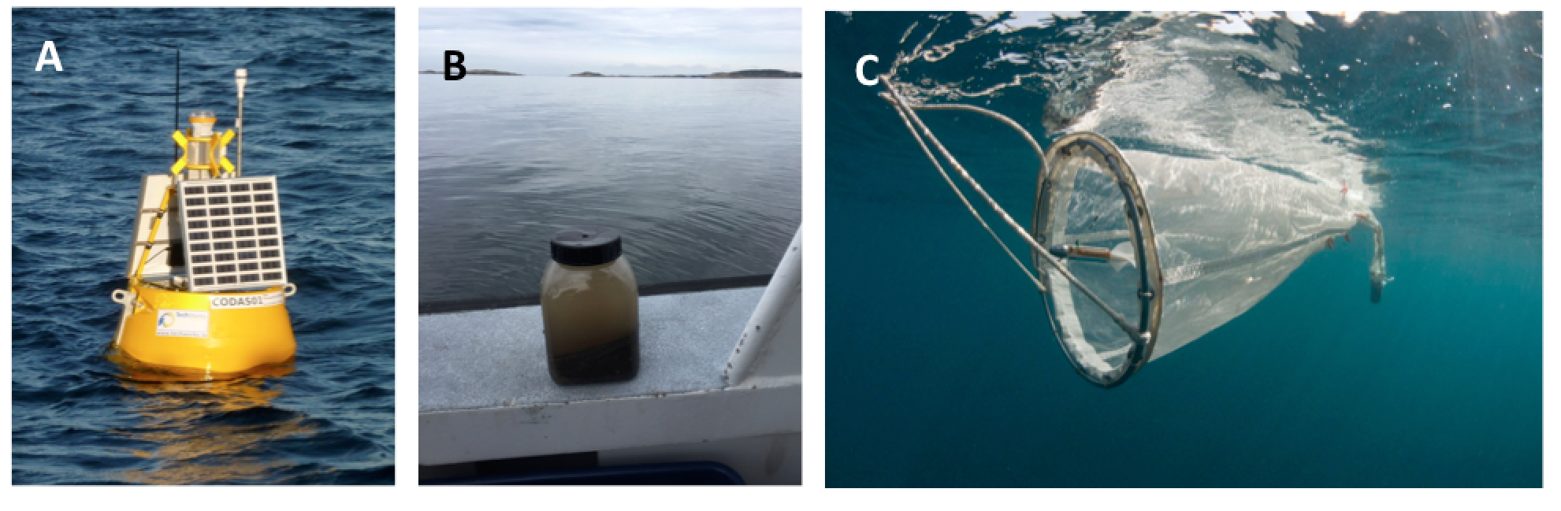

***Fig 3.*** *Potential supplementary measurements.* ***A.*** *Coastal buoys may be in the vicinity of ARMS sites and provide continuous physico-chemical data on e.g. temperature, salinity, chlorophyll concentration, turbidity, or currents.* ***B.*** *Sediment samples (app 500 ml volume) may be obtained during the ARMS retrieval, either using a Van Veen grab or a diver. C. Plankton samples (vertical hauls) may be obtained the ARMS retrieval, using plankton net with 100 micron mesh size.*

Sample conservation and shipment

In the first cycle we collected samples in both 95% EtOH and DMSO, and we need to decide before August 2019 how we preserve our samples in the second cycle. The experience from some partners suggested that EtOH is better for preserving plant DNA, while DMSO is better for animal DNA. We also realised that DMSO has a large advantage over EtOH, because it can be shipped without problems and seems to preserve as well as EtOH (<https://doi.org/10.1093/mollus/eym039>). We plan to make a decision based on the preliminary results from 2018. The recipe we use is DMSO salt-saturated buffer (20% DMSO, 0.25 M EDTA, pH 7.5, NaCl saturated (Seutin G, White BN, Boag PT (1991) Preservation of avian blood and tissue samples for DNA analyses. Can J Zool 69:82–90).

Access and Benefit Sharing (ABS)

About Access and Benefit Sharing (ABS) documents, we include Material Transfer Agreement (see Appendix), which you can fill in, print out, and sign, and then add one copy to the sample shipment.

Sample labelling and shipment

Please prepare the samples in the following way

1. If you send EtOH samples, remove most of the Ethanol as possible from the samples to avoid complicated shipment procedure.
2. Make sure all samples are properly labelled with the following information. Please use a printed label and not writings on the falcon tube, which can be removed by Ethanol (see Fig 4)

**Sample-ID: VH2-MF100-ETOH**

Sample date: 2018-09-04

PI Name: Matthias Obst

Project-ID: KosterARMS

ARMS-ID: VH2

In/out: (4MAY-4SEP2018)

Sample type: motile fraction

Fraction: 100 micro meter

Wet weight: 30 g

Preservation: DMSO

In the perfect scenario a single replicate may contain

* + 3 samples from each ARMS (1 sessile fraction and 2 motile size fractions),
  + 2 samples from soft sediment (2 size fractions),
  + 1 plankton sample (1 size fraction)

1. Add a printout of metadata sheet (see appendix), sample overview sheet (see appendix), and the signed Material Transfer Agreement (see appendix), and make sure that the ARMS-ID in the metadata sheet is the same on the sample labels and in the Material Transfer Agreement.
2. Ship the sample to the following address:

Melanthia Stavroulaki and Paraskevi Polymenakou

Institute of Marine Biology, Biotechnology and Aquaculture

Hellenic Centre for Marine Research

(former USA Base) Gournes Pediados

71500 Heraklion Crete

Greece (Hellas)

 Tel: +30-2810-337801, +30-2810-337840, +30-2810-337855

Email: Melanthia Stavroulaki <mstavroulaki@hcmr.gr>

1. Send an email to *Melanthia Stavroulaki* and *Matthias Obst* with the shipping details and dates. When the samples arrived, Melanthia will send you a short receipt email with a photo copy of the bilaterally signed Material Transfer Agreement.

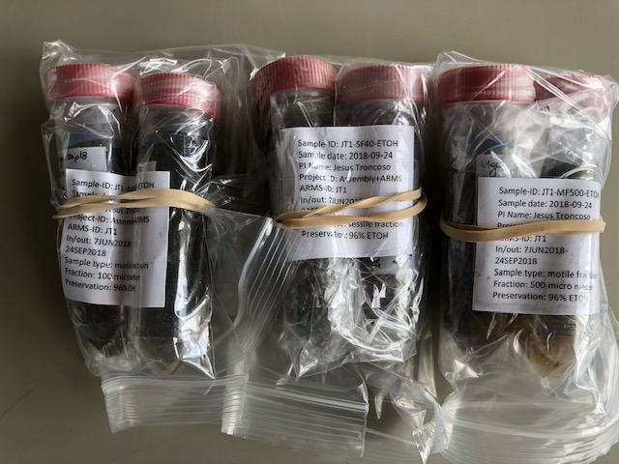

***Fig 4.*** *Samples ready for shipment.*

Technical details

**Base plate.** In many cases it is difficult to attach the ARMS to the sea floor. For this reason we generated a manual for a concrete base plate (see Fig 5). It contains 4 screws (distance between screws: 27.5 cm on short edge, and 37.5 cm on long edge). The base plate has a separate hole that allows attaching ropes for an underwater buoy and lifting up the plate separately from the ARMS

Rectangular form 53 cm on the long edge and 48 cm on the short edge. Total volume of concrete app

22 L. Total weight app 52 kg on land and app 30 kg in the water.

**Cover container.** In order to capture all motile and epi/hyperbenthic fauna on the ARMS we use a plastic container, which is put over the ARMS before retrieval. The container can be secured with rubber ropes to ensure it does stay attached to the ARMS on the way to the surface (see Fig 5).

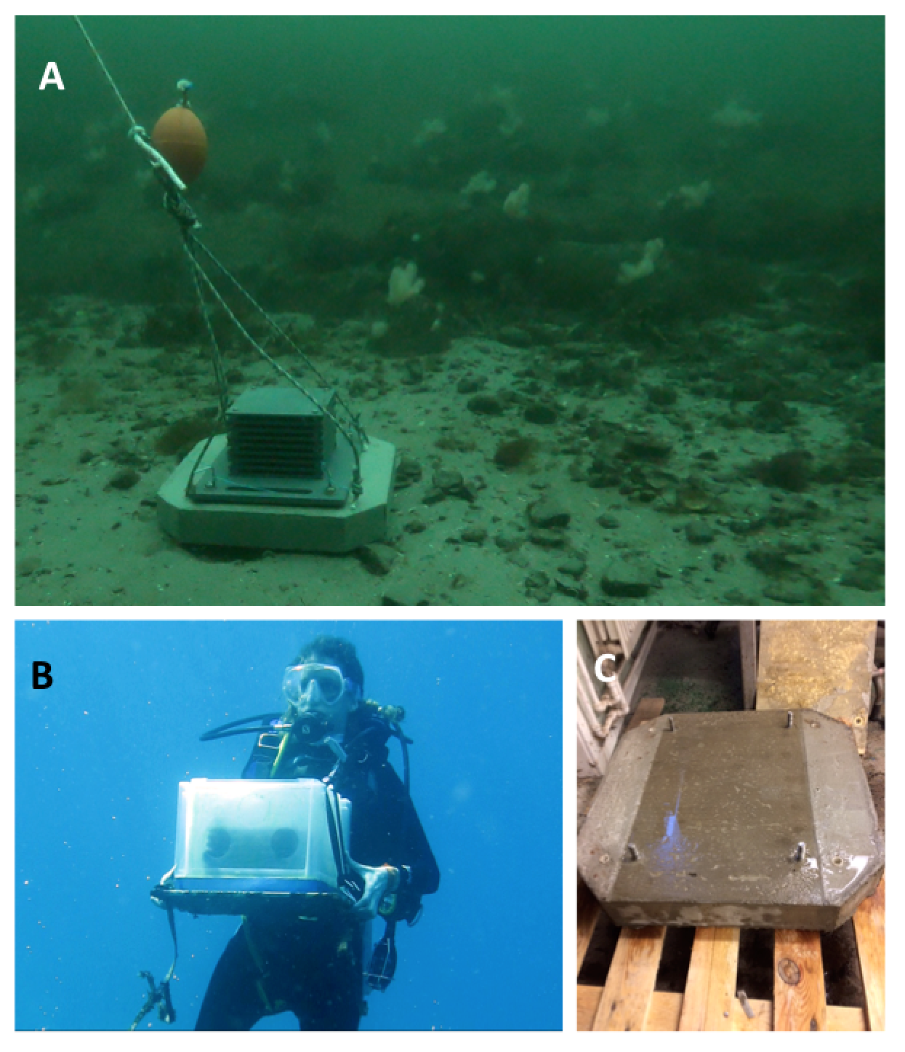

***Fig 5. A.*** *Photograph showing ARMS deployment.* ***B.*** *Photograph of the plastic container that is put over the ARMS on the sea floor before retrieval.* ***C.*** *The concrete base used to attach the ARMS to the sea floor.*

Data flow

We will focus on the data flow in second half of 2019 (see Fig 6). Please save all images, measurements, field notes from the ARMS plates. We will ask you to submit them to the Marine Data Archive at a later stage.

|  |
| --- |
|  |
| ***Fig 6.*** *Tentative overview over the data flow as anticipated for the ARMS program. Metadata are collected during deployment phase and used to link the different types of raw data across relevant archives.* |

# Appendices

The following files can be found in the GitHub repository (together with the latest version of the handbook) <https://github.com/biomobst/ARMS>.

1. Project registration sheet (only relevant for new partners)
2. Metadata sheet (template)
3. Metadata sheet (example)
4. Sample overview sheet
5. Material Transfer Agreement (MTA)